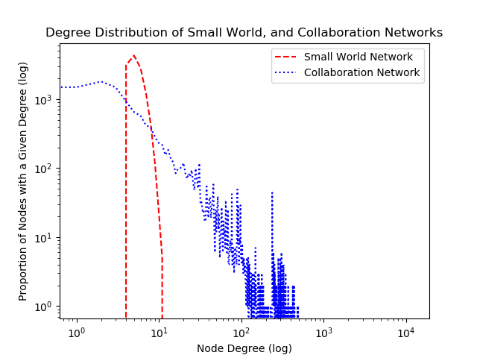

**Q) Difference between the collaboration networks degree distribution and the degree distributions from the random graph model:**

A) Degree distributions of collaboration networks are often highly skewed and quite difficult from the distribution of the random graph model.

Average Clustering Coefficient for Small World Network: 0.303260

Average Clustering Coefficient for Scientific Collaboration Network: 0.611483

***CELF for Small World Network***

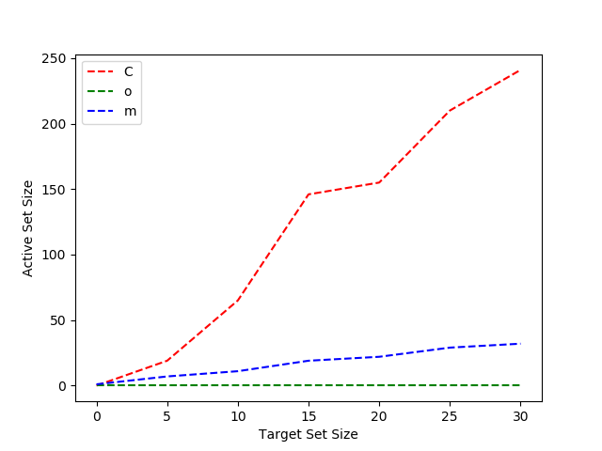

***4.CELF for Scientific Collaboration Network***

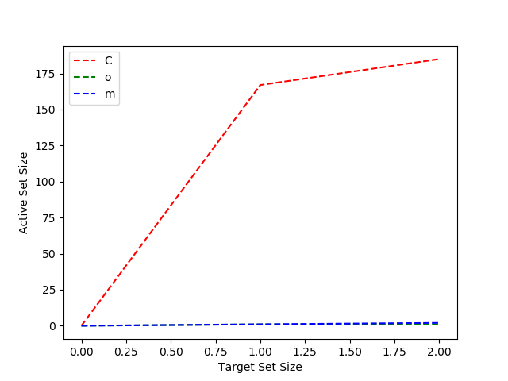

5.

What I felt is that in the first network which is the small world network the edges are very slow which made the influence by single node lesser when compared with the second network which is the scientific collaboration network. The second network has lot of edges which takes lot if time for execution and also for each node the influence it does is larger then the previous one.

What I also observed is that taking celf, degree centrality and random walk I felt celf influence set will find the actual influence nodes in the network with better rates than the other two.